1. <https://www.youtube.com/watch?v=T0TynxN77oY>
2. The following categorization is based on Level of testing.
3. **Unit Testing**:
   1. It is done during Development/Coding phase.
   2. The smallest part of software such as a function, class, or a module is called unit and is tested.
   3. There are further two categories.  
      **NOTE**: Actually, these are not further two categories but the way of designing the test cases.
      1. **Black Box**:
         1. We will give just input and check the output.
         2. **Example**: We have a car to be tested. We will drive it and check the output. We will not focus on engine or tyres.
      2. **White Box**:
         1. But in white box, we will design the test cases based on internal structure (means code).
4. **Integration Test**:
   1. When units are combined, it becomes module which is tested and such testing is called integration testing.
   2. Why do we need it when we have already tested units?
      1. After integration, we want to check if they are compatible.
   3. There are 4 further types.
5. 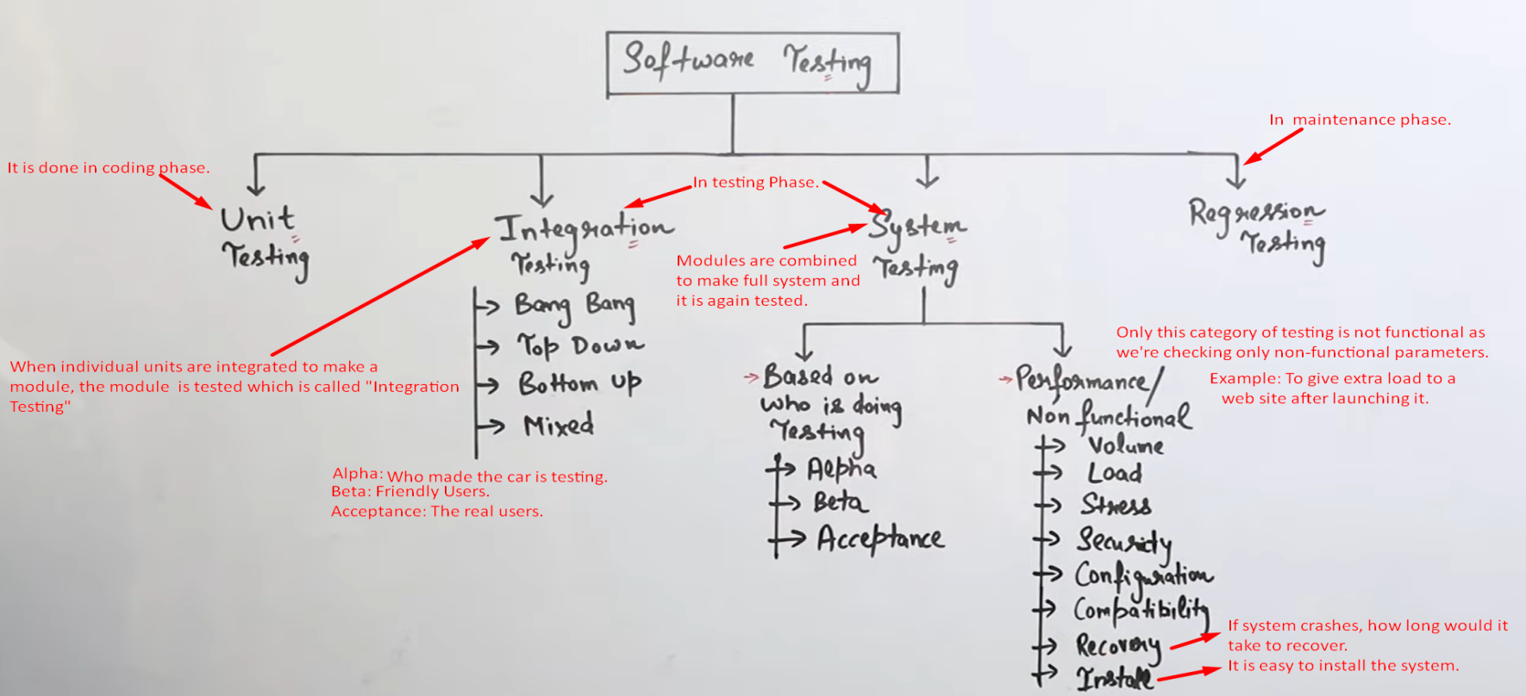
6. **Regression Testing**:
   1. Whether upgrade is not disturbing the already working components.